Assignment: Day-4 Subnetting

1. Divide 192.168.10.0/24 into 4 Equal Subnets
Subnet | Network Address | Usable Host Range | Broadcast Address
Subnet 1 | 192.168.10.0/26 | 192.168.10.1 - 192.168.10.62 | 192.168.10.63
Subnet 2 | 192.168.10.64/26 | 192.168.10.65 - 192.168.10.126 | 192.168.10.127
Subnet 3 | 192.168.10.128/26 | 192.168.10.129 - 192.168.10.190 | 192.168.10.191
Subnet 4 | 192.168.10.192/26 | 192.168.10.193 - 192.168.10.254 | 192.168.10.255

2. Device IP Assignment (Subnet 1)
Device | IP Address
Router | 192.168.10.1
Laptop 1 | 192.168.10.2
Laptop 2 | 192.168.10.3
Printer | 192.168.10.4
Mobile | 192.168.10.5

3. Subnet Plan Diagram
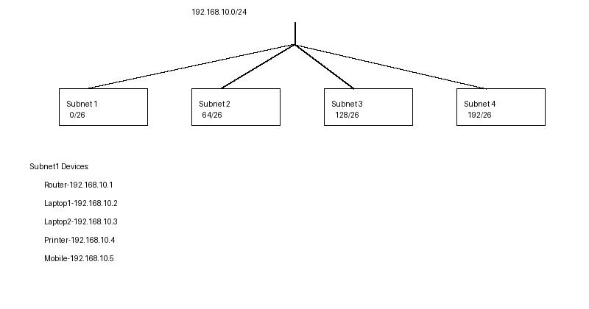

4. Step-by-Step Calculation
1. Start with network 192.168.10.0/24 (256 addresses).
2. Need 4 subnets, so borrow 2 host bits (2^2=4).
3. New subnet mask becomes /26 (255.255.255.192).
4. Each subnet has 64 addresses and 62 usable hosts.
5. Subnets increment by 64: 0, 64, 128, 192.
6. Assign valid host IPs, avoiding the network and broadcast addresses.

